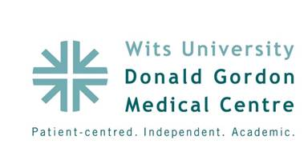

**Poster Abstract: P8**

**Title:**

**Resistant Clostridium Difficile infection and faecal transplantation in patients with inflammatory bowel disease at Wits Donald Gordon Medical Centre**

**Authors:**

KA Karlsson, P Barrow

**Aim:**

Clostridium difficile (C Diff) infection is becoming an increasing problem worldwide and especially in patients with inflammatory bowel disease. A treatment that has been described for resistant cases is faecal transplantation to reintroduce normal flora to the gut. The aim of this project was to describe the experience of faecal transplantation at Wits DGMC

**Objectives:**

To describe the reasons and outcomes of the first three patients treated with faecal transplantation

**Methods:**

We treated three patients with faecal transplantation between January 2012 and March 2013. All patients had C diff infection as diagnosed by PCR of stool samples. Patient records were assessed for history, treatment and post faecal transplantation stool PCR results. All three patients had colitis and had been treated with standard therapy before electing to try faecal transplantation. Donors were approached and screened. Stool was liquidized with sterile water and 50 ml was given using a nasogastric tube.

**Results:**

Four weeks after transplant a repeat faecal C diff PCR was performed and was negative in all three cases

**Conclusion:**

Faecal transplantation is a possible and successful treatment for resistant C diff infection of the gut.