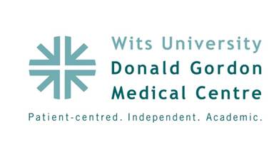

**Poster Abstract: P7**

**Title:**

**Multi Drug Resistant Organisms at WDGMC, a Private Health Care Facility**

**Authors:**

Ronel Senekal, Warren Lowman

**Aim:**

Our aim is to describe the most dominant Multi Drug Resistant Organisms (MDROs) in our establishment and more specifically those acquired in hospital. We will describe the impact and challenges associated with identification of these organisms and the impact on the nursing environment in a South African private healthcare setting.

**Objectives:**

The primary objective is to identify and highlight the most dominant MDROs in our health care setting in the context of a surveillance system. Additionally we report on the impact of this surveillance in the early identification and implementation of infection prevention and control measures.

**Methods:**

MDRO infections are identified according to standardized CDC definitions. Data is collected by means of reports received from pathology services and an integrated electronic system. Only clinical samples were used for identifying MDRO infections. Data (MDRO rates) assessed by both prevalence and incidence.

**Results:**

The data presented is over a period of six months. A total of 235 clinical samples were identified of which 79 were identified as hospital- acquired infections (HAIs). There is a linear correlation between incidence of HAIs and prevalence of MDROs.

**Conclusion:**

MDROs are typically viewed as being pathogens of HAIs, however in-hospital prevalence of MDROs plays an important role in HAI incidence. Early identification and analysis of epidemiological information, based on accurate surveillance data are imperative in preventing the spread of these organisms.