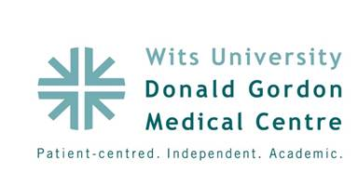

**Poster Abstract: P4**

**Title:**

**Improving antimicrobial surgical prophylaxis in a highly specialized surgical environment serving solid organ transplant and oncology patients**

**Authors:**

Estella L Minnaar (1), Dr Warren Lowman (1,3), Ronel Senekal (1), Andriette Van Jaarsveld (2)

1. Wits Donald Gordon Medical Centre;
2. Mediclinic Southern Africa
3. Vermaak & Partners/ Pathlink Laboratories

**Aim:**

Wits Donald Gordon Medical Centre (WDGMC) is a 190 bed private hospital and serves as a referral centre for complex surgical patients. Surgical site infections (SSis) are one of the leading causes of morbidity1,2 thus we selected antimicrobial surgical prophylaxis as a “low-hanging fruit”3 for our antimicrobial stewardship program. Our aim was to assess and improve on various components of antimicrobial surgical prophylaxis.

**Objectives:**

To assess current status in terms of appropriateness of choice of antimicrobial agent for surgical prophylaxis and identify problem areas; to improve antimicrobial selection and compliance with guidelines; to assess the impact of interventions in reducing inappropriate use of antimicrobials for surgical prophylaxis.

**Methods:**

A retrospective analysis of the Mediclinic Utilization Report and an –audit of intra-operative patient records was conducted. An awareness campaign was launched where anaethetists and surgeons were invited to an antimicrobial stewardship information, feedback and discussion session. Feedback was obtained before the final version was implemented. To improve compliance, formulary restriction was implemented, strictly limiting which antimicrobials are available in theatre. Agents not on the guidleline are to be ordered from pharmacy via a preauthorization system. Currently no orders are rejected by the pharmacy.

**Results:**

An annotated Run Chart was used to assess the impact of the interventions on the number of inapproporiate antimicrobial surgical prophylaxis cases per month which fell significantly from an initial median of 32.5 to 15.5 cases per mont, a drop of 50%. Formulary restriction was not fully embraced at first by the medical staff. In addition, formulary restriction can cause delays in therapy due to the pre-authorization process including completeing forms and collection of the antimicrobial agent from pharmacy.

**Conclusion:**

Antimicrobial surgical prophylaxis which was initially perceived as a “low hangingfruit” can be challenging. Powerful evidence based strategies like formulary restriction and pre-authorization might be necessary to achieve success. An organisational-specific guideline may be essential in specialised settings.