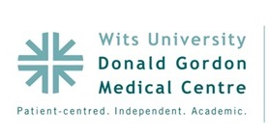

**Oral Presentation Abstract: O1**

**Title:**

HIV Infection and Older Adults

**Authors:**

India Butler, Brent Tipping, William McLeod.

As the HIV infected population ages and the incidence of newly diagnosed older adults appears to be increasing, clinicians will be challenged by “clinically old” HIV infected patients with multiple co-morbidities and complex medication prescriptions. Guidelines are drawn up based on information from younger patients with lower rates of co-morbidity and thus may not be appropriate for an older population. HIV infected older adults in South Africa have unique demographic, epidemiological and social characteristics. There is a lack of data about this group. Research from other countries can guide clinicians in South Africa, but local research is vital to understand the particular needs of this population. The purpose of this study was to describe the cohort of HIV-infected older patients at Themba Lethu Clinic following initiation of ART and 12 months later. Treatment outcomes at 12 month follow up and any associations were also described.